République Algérienne Démocratique Populaire
Ministere de l'Enseignement Superieur et de la Recherche Scientifique
Université de Science et de la Technologie Houari Boumediene
U.S.T.H.B
Faculté d’Informatique


Projet Finale TIC :

information and communication technology (ICT)

Préparé par le groupe :
 | nom | prenom | matricule
Etudiant_1 | Chatri | Med Amin Ismail | 232331639907
Etudiant_2 | Khelifli | Abdessamed Islam | 232331674715
Etudiant_3 | Bekkai | Lyna | 232331632202
Etudiant_4 | Boukabes | Adem | 232331674601
Etudiant_5 | Ameziane | Manel Fatma | 232333151813

- plan
2 Introduction about Information and Communication Technologies (ICT) 2
2.1 what is information and Communication Technologies (ICT)? 2
2.2 Some examples about Information and Communication Technologies : 2
3 Overview of google services : 3
3.1 Google Workspace: 3
3.2 Google Cloud Platform (GCP): 3
3.3 Google Chrome: 3
3.4 Google Search: 3
3.5 Android OS: 3
3.6 Google Workspace for Education: 3
3.7 Privacy and Security: 3
3.8 Integration with Third-Party Services: 3
3.9 Recent Developments and Updates: 3
3.10 Challenges and Concerns: 3
4 Overview of microsoft tools : 4
4.1 Artificial Intelligence (AI): 4
4.1.1 PowerPoint Designer: 4
4.1.2 Excel Insights: 4
4.1.3 Word Editor: 4
4.1.4 Outlook Focused Inbox: 5
4.2 Cloud Computing: 5
4.3 Collaboration and Communication: 5
5 An Overview of Git and GitHub 5
5.1 Introduction : 5
5.2 Git: The Version Control System: 6
5.2.1 Key Concepts: 6
5.2.2 Workflow : 6
5.3 GitHub: Collaboration and Project Management: 6
5.3.1 Collaboration Features: 6
5.3.2 Project Management: 7
5.4 Collaboration and Open Source 7
5.5 Conclusion: 7

- Introduction about Information and Communication Technologies (ICT)

  - what is information and Communication Technologies (ICT)?

Information and Communication Technologies (ICT) encompass a wide range of technological tools and resources used to transmit, store, create, share, or exchange information. This includes computers, the Internet, live and recorded broadcasting technologies, and telephony. ICT is the infrastructure and components that enable modern computing, with the goal of improving the way humans create, process, and share data or information with each other. It also encompasses emerging technologies such as 5G/6G, Web3, and quantum computing, as well as traditional technologies like landline telephones, radio, and television. ICT is a rapidly growing field that plays a vital role in various areas, including business, education, medicine, and real-world problem-solving. The proper application and use of ICT technologies can benefit individuals and organizations across different sectors .

  - Some examples about Information and Communication Technologies :
. .
 | material | No material
examples about Information and Communication Technologies | Computers and laptops | The Internet and WiFi
examples about Information and Communication Technologies | Smartphones and tablets | Social media platforms
examples about Information and Communication Technologies | Electronic health records and telemedicine technologies. | Email and instant messaging services.
examples about Information and Communication Technologies | Wearable technology such as smartwatches and fitness trackers. | Video conferencing and distance learning tools
examples about Information and Communication Technologies | Digital broadcasting technologies such as satellite and cable TV. | Live video streaming platforms such as YouTube and Twitch
examples about Information and Communication Technologies | Radio and television broadcasting technologies.  . | Cloud computing services such as Google Drive and Dropbox.  .
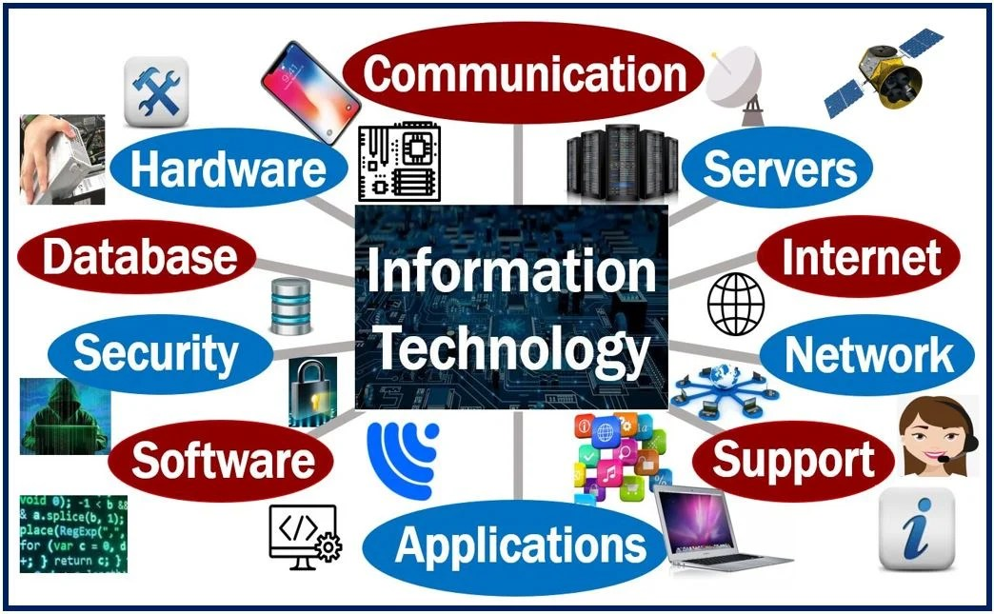

- Overview of google services :

Provide a brief introduction to Google as a technology company. Highlight the diversity of services they offer in the ICT domain.

  - Google Workspace:
Formerly known as G Suite, Google Workspace is a suite of cloud computing, productivity, and collaboration tools. Discuss key components such as Gmail, Google Drive, Google Docs, Sheets, Slides, and Google Meet. Emphasize collaborative features, real-time editing, and cloud storage.
  - Google Cloud Platform (GCP):
Introduce Google's cloud computing services, including infrastructure, storage, and machine learning capabilities. Discuss how businesses can leverage GCP for hosting applications, storing data, and running analytics.
  - Google Chrome:
Explore the significance of Google Chrome as a web browser. Highlight features like speed, security, and integration with other Google services.

  - Google Search:
Briefly discuss the importance of Google Search in information retrieval and its impact on communication.
  - Android OS:
Mention Google's mobile operating system and its dominance in the smartphone market. Highlight how Android contributes to communication through various apps and services.
  - Google Workspace for Education:
If applicable, discuss Google's suite of tools tailored for educational institutions.Emphasize features like Google Classroom, Google Forms, and collaborative learning.
  - Privacy and Security:
Address privacy concerns and security measures implemented by Google to protect user data. Discuss encryption, authentication, and other security features.
  - Integration with Third-Party Services:
Highlight how Google services can be integrated with other third-party tools and applications for a seamless user experience.
  - Recent Developments and Updates:
Include information on any recent updates, new features, or innovations in Google services.
  - Challenges and Concerns:
Acknowledge any challenges or criticisms related to Google services, such as privacy issues or potential monopolistic behavior.

- Overview of microsoft tools :

  - Artificial Intelligence (AI):
Microsoft has been integrating AI into their tools, such as Office 365, Azure, and Bing. This includes features like real-time translation, smart suggestions, and intelligent search, making your work more efficient and personalized.Microsoft has integrated AI in various ways across their tools. Here are a few more examples:

    - PowerPoint Designer:


AI-powered Designer feature in PowerPoint suggests design ideas for your slides based on the content you provide, making it easier to create visually appealing presentations

    - Excel Insights:


In Excel, you can use the Insights feature powered by AI to analyze your data and get automated suggestions for charts, pivot tables, and other visualizations, helping you uncover patterns and trends.

    - Word Editor:


With AI-driven Word Editor, you can improve your writing by receiving suggestions for grammar, style, and clarity. It helps you polish your documents and make them more professional.

    - Outlook Focused Inbox:

AI in Outlook helps you prioritize your emails by automatically sorting them into
the Focused Inbox, which highlights important messages and filters out less important ones, saving you time.

  - Cloud Computing:
Microsoft Azure is a powerful cloud computing platform

that offers scalable storage, computing power, and analytics
. It allows businesses to build, deploy, and manage applications
and services on a global network of data centers.

  - Collaboration and Communication:
Microsoft Teams is a popular collaboration platform that

combines chat, video meetings, file storage, and app
integration. It enables teams to work together seamlessly,
whether they are in the same office or spread across different locations.

- An Overview of Git and GitHub

  - Introduction :

Git and GitHub are powerful tools that have revolutionized version control and collaborative software development. Git, created by Linus Torvalds, is a distributed version control system (DVCS) designed to track changes in source code during software development. GitHub, on the other hand, is a web-based platform built on top of Git, providing a centralized hub for collaborative coding, version control, and project management.

  - Git: The Version Control System:

Key Concepts:
Git operates on a decentralized model, allowing multiple contributors to work on a project simultaneously without conflicts. Key concepts include:

- Repositories: Git stores project files and their revision history in repositories.
- Commits: Each change made to the codebase is recorded as a commit, containing a unique identifier, author information, and a snapshot of the changes.
- Branches: Git allows the creation of branches, enabling developers to work on features or bug fixes independently before merging them back into the main codebase.
- Merging: Changes from different branches can be merged to create a unified codebase.

Workflow :

Common Git workflows include:
- Centralized Workflow: Single master branch, suitable for smaller projects or solo developers.
- Feature Branch Workflow: Developers create separate branches for features, bug fixes, etc., and merge them back into the main branch.
- Gitflow Workflow: A branching model defining specific branches for features, releases, and hotfixes.

  - GitHub: Collaboration and Project Management:

Collaboration Features:

GitHub extends Git functionality with collaborative features:
- Pull Requests: Developers propose changes, discuss, and review code before merging.
- Issues: Tracking bugs, enhancements, and tasks in a project.
- Wikis: Documentation for projects, editable by collaborators.
- Actions: Automation workflows triggered by events like pushes, pull requests, or issues.

Project Management:

GitHub provides tools for project management :
- Projects: Kanban-style boards to organize and prioritize work.
- Milestones: Groups of issues that represent a project's scope or a specific release.
- Security Features: Dependency scanning, code analysis, and vulnerability alerts to enhance project security.

Collaboration and Open Source

GitHub has played a significant role in the growth of open-source software:
- Forks: Developers can create personal copies (forks) of a repository to propose changes.
- Pull Requests: Developers contribute changes to the original project via pull requests.
- Community: GitHub fosters a collaborative community around open-source projects.

Conclusion:

Git and GitHub have become integral tools for modern software development, enabling efficient version control, collaboration, and project management. Understanding the principles and workflows associated with Git and leveraging GitHub's collaborative features can greatly enhance the development process and facilitate open-source contributions.

